International Conference

Host: Open Radio for North Korea, Korea Communications Society
Sponsor: Korea Press Foundation
November 22, 2010

Media and North Korea under Kim Jong-eun Regime:
an American Perspective

Donald Kirk

Summary

North Korea under Kim Jong-eun is likely to focus more than in the past on getting foreign journalists to write highly favorable articles. This approach was evident in the coverage of the parade on October 10 at which Kim Jong-eun stood beside his father on the reviewing stand. Foreign journalists generally wrote effusive articles. Foreign journalists will have to rely more than ever on reports picked by small South Korean radio stations, such as NK Open Radio, and news agencies, such as Daily NK. The North Korean media will remain a major source of news and quotes regarding events in North Korea.
At the same time, the United States continues to provide much of the financing for these stations and news agencies while broadcasting into North Korea on major government networks, Voice of America and Radio Free Asia. The size of the listening audience for these networks is not clear, but extensive surveys suggest that an appreciable if unknown number of North Koreans occasionally tune in to their broadcasts. It’s likely these efforts will increase after Kim Jong-eun assumes power.
The uncertain impact of attempts to bring news to North Koreans is matched by the uncertain reliability of fragmentary reports from North Korea. Clearly, however, North Korean authorities are highly sensitive both to what’s reported about North Korea and to what news penetrates the barriers into North Korea.
This state of tension will doubtless increase after Kim Jong-eun assumes the mantle of power. It’s possible that considerably more news will come out of North Korea, and go into North Korea, but no one can predict when, if ever, that’s going to happen. The IT revolution, however, has inevitably opened the North to greater closep-up scrutiny than ever before.

I. Strategic Opening

The Kim Jong-eun regime, whenever it rises to power, is certain to carry on the same policy of total media control as that of Kim Jong-eun’s father and grandfather. From an American perspective, the challenge will be to get correspondents for U.S. news organizations into Pyongyang and to bring news into North Korea. It would seem unlikely that journalists would be able to go there on anything other than carefully scripted, brief visits in which they are constantly escorted by “minders” skilled at showing whatever the regime wants them to see, beginning with the obligatory bow before the great bronze statue of Kim Il Sung atop Mansudae in front of the “Korean Revolutionary Museum” with its huge mosaic of Mount Paektu.
For correspondents, the challenge will remain to try to pry information from diplomatic sources, often made unavailable or unreachable, to glean insights from observations while going from sight to sight in a tourist van, and, of course, to pick up material from experts outside Korea. The North Korean authorities are extremely skillful and disciplined in controlling those few correspondents to whom they grant visas. Hitherto journalists have generally been able to attend the Arirang festival, an event that goes on for many weeks in May Day stadium with a cast of tens of thousands and to go as tourists while disguising their identity as journalists.
Nearly 80 foreign journalists got into Pyongyang for the great parade on October 10, 2010, the 65th anniversary of the Workers’ Party at which Kim Jong-eun appeared on the reviewing stand with his father, Kim Jong-il. The purpose was to introduce Kim Jong-eun for the first time in public before the world, confirming his role as heir apparent to his ailing father. There was even a media center in the Koryo Hotel from which journalists could file their reports along with live television coverage.
The event did not, however, show a new openness on the part of North Korean authorities. Some of the journalists who stayed on for several more days wrote effusively laudatory stories. The success of the North Korean information machine was evident in an Associated Press report that began with the line, “North Korea may be struggling to feed its people, but there was no shortage of mouthwatering options on the menu at our guide's favorite restaurant: ostrich, duck and beef; scallops, crab and lobster; pancakes, stews, noodles and even spaghetti.” The correspondent sought to give an impression of a certain independence. “Breaking away from the gaggle of foreign reporters allowed into the country for the festivities, we ate traditional North Korean fare for lunch,” she wrote. “Afterward, we wandered along the scenic Taedong River, stopping to chat with families picnicking along its grassy, willow-lined banks.” She “had squealed with delight” when guides asked if she and the AP photographer, Vincent Yu, who was with her, would like to go to a fair. And when she and the photographer got back to the hotel after midnight, Yu “shook his head and asked aloud: ‘Was it real?’”
The question may have been rhetorical, but the answer was plain. No, it was not real. The occasion was a show for the world, and no questions were raised about the gulag system in which 200,000 people were generally incarcerated, new prisoners replacing those were executed, starved to death or died prematurely of some dread disease. There was no reference to the hunger suffered by all but a privileged elite in the party, the government and the armed forces, no mention of the North’s reliance upon China for food and other aid, of the World Food Program’s attempts to make up for the shortfall of food in certain regions, no passing allusion to the lack of medical care, no hint of the suffering of the country and its people. Nor did the story allude to what the AP and others had often reported from Seoul, namely the North’s demands that South Korea resume sending hundreds of thousands of tons of rice and fertilizer to the North as the South had done during the decade of the Sunshine policy, initiated by Kim Dae-jung at the outset of his presidency in 1998, maintained by Kim’s successor, Roh Moo-hyun, and finally stopped when the conservative Lee Myung-bak took office in February 2008.
As this type of reporting suggested, however, a new regime in North Korea might conceivably adopt an imaginative approach toward winning the hearts and minds of selected correspondents. The possibility remained that more journalists might get into the country on carefully staged visits, and the possibility might increase over the years if Kim Jong-eun showed signs of an independent approach somewhat different from that of his uncle, Jang Song-thaek, husband of Kim Jong-il’s younger sister, Kim Kyong-hui, a powerful figure in her own right. There was no way, however, to confirm such speculation. North Korean authorities will have more chances to invite the foreign media for specific occasions. One might be the funeral for Kim Jong-il, who suffered a stroke in August 2008 and was clearly limping at the ceremony on October 10. Another will surely be the ceremonies in 2012 marking the 100th anniversary of the birth on April 15, 2012, of Kim Il-sung. The fun will go on for weeks, climaxing on the anniversary day with celebrations all over the country to which foreigners will surely be invited.

II. News for the North
When not going on escorted tours to North Korea, foreigners can rely increasingly on reports on South Koran websites whose writers and editors obtain information from North Korea from mobile phone contacts that were totally unavailable a few short years ago. The websites of Ha Ta-keung’s Open Radio and North Korea Reform Radio, another Seoul-based station, as well as those of two South Korean NGOs with contacts in North Korea, Daily NK and Good Friends, neither of which broadcast into the North but are a source for North Korea-watchers. Kim Seung-chul, speaking for North Korea Reform Radio in an interview with The Korea Times, summarized his view of the impact on reporting of North Korea’s disastrous attempt at economic reform in late 2009 and early 2010. The regime “was almost forced to allow the reopening of markets in the wake of the failed currency reform,” he said. “They realized that the people are not what they used to be….Now these people know how the outside world works as they can access uncensored information by secretly tuning into radio programs or reading leaflets.”
Websites of these and other organizations put out news in English and Korean on what their contacts tell them is going on inside North Korea, providing windows into the North that did not exist until several years ago. This kind of reporting is at the forefront of a high-tech information explosion whose impact is not exactly clear. On the one hand, it’s far easier now than it was five or ten years ago to broadcast into North Korea and, on the other hand, mobile telephones arm contacts with the means to get through to the South at the risk of being caught and punished severely. Many of the contacts, along the Yalu and Tumen river borders with China, use Chinese mobile phone services. A few are deeper inside North Korea; some in southern regions not far from the Demilitarized Zone rely on South Korean services. The information they provide is not uniformly reliable, and reports may be at variance. Still, those North Koreans who dare to tune in know much more about South Korea, the region and the world, and foreign audiences know much more about North Korea, than was imaginable before 2005 or 2006 when small stations in Seoul began regular broadcasts into the North.

Open Radio competes with three other Seoul-based stations, Radio Free Chosun, North Korea Reform Radio and Free North Korea Radio. They are all quite different. Open Radio broadcasts four hours daily into North Korea, two hours on short wave, one on AM and the fourth on FM; Radio Free Chosun broadcasts three hours a day, all short wave; North Korea Reform Radio broadcasts one hour daily, short wave; Free North Korea Radio at one stage was broadcasting five hours a day on three short-wave bands. Open Radio offers soap operas and a fictionalized serial that makes much of a potential rivalry between Kim Jong-eun, Kim Jong-il’s third son and heir presumptive, and Jang Song-thaek, Kim Jong-il’s brother-in-law, who may have visions of ruling as a regent, a power behind the throne, after Kim Jong-il leaves the scene.
Radio Free Chosun, a cooperative operated by activists and defectors, and North Korea Reform Radio and Free North Korea Radio, owned by defectors, are both regarded as more fiercely political than Open Radio. “Stations such as Free North Korea Radio, Radio Free Chosun, Open Radio North Korea and North Korea Reform Radio are the best way to open a breach in Pyongyang’s mind-destroying propaganda,” said Reporters Without Borders in a ceremony in November 2009 at which Kim Seong-min, founder of Free North Korea Radio, who defected to the South in 1996, won a prize from the anticommunist Taiwan Foundation for Democracy for “courageous defiance” of the North Korean regime.
These stations, distinctive and determined as they are, face different and stronger competition from two U.S. government networks, Voice of America and Radio Free Asia, focusing on North Korea with mounting intensity as a dividend of the North Korea Human Rights Act passed by Congress in 2004 that authorized funding for more programming and more people, mostly Koreans. VOA, broadcasting since 1942, had been slow to penetrate the obstacles to reaching listeners in North Korea. Its Korean service went from three to three hours and 30 minutes a day in 2006 and in 2007 to five hours a day on four bands, two short wave and two medium wave, while the number of Koreans on the payroll rose from 20 to 40 in Washington and several more in a newly opened office in Seoul next to the bureau of the American correspondent responsible for filing for VOA in English. In its broadcasts for North Korean listeners, VOA hews to the factual analytical tone of its reporting in other languages, notably English, for a global audience outside the U.S., where it’s banned from broadcasting by congressional fiat.
Radio Free Asia, having begun broadcasting to North Korea in 1997, increased broadcast time to five hours a day on eight bands, four short wave and four medium wave, and opened a bureau in Seoul more or less in tandem with VOA. From the outset, however, RFA has differed from VOA in the outraged tone of its reports and commentary, often picking upon scandals, human rights violations and other wrongdoing in a muckraking style. The service signaled its crusading approach in a statement of purpose that noted that Freedom House in New York “ranks North Korea dead last in its annual press freedom index and gives it the lowest possible rating for both political rights and civil liberties and Reporters Without Borders ranked the dictatorship 174 out of 175 in their 2009 Media Freedom Index.” The statement cited a State Department human rights report describing North Korea as “a dictatorship under the absolute rule of Kim Jong-il” where “members of the security forces have committed numerous serious human rights abuses” including “extrajudicial killings, disappearances and arbitrary detention” while political prisoners were consigned to “harsh and life-threatening prison conditions” that included “forced abortions and infanticide.”
That said, RFA aspires to “offer a faint glimmer of the outside world that is growing somewhat brighter as more citizens take the risk to reset their fixed radios to stations beyond the DPRK” despite the omnipresent fear of 10-year jail terms said to be “common for accessing foreign media.” RFA is proud of a six-part series produced in 2009 exposing the plight of North Korean refugees in China and “the harsh conditions facing child defectors and the human trafficking of North Korean girls and women.” RFA won a David Burke award from the Broadcasting Board of Governors for a series produced in 2006 in which a defector working for RFA returned to China and “interviewed 14 North Korean women who had fallen victim to criminal gangs of traffickers on both sides of the border.” The station had no doubt someone was listening. Kim Jong-il, it alleged, had “fired a number of officials after RFA exclusively reported on corruption involving the North Korean agency that handles humanitarian aid and South Korean investment in the North,” though how RFA knew that Kim had done the firing was not revealed.

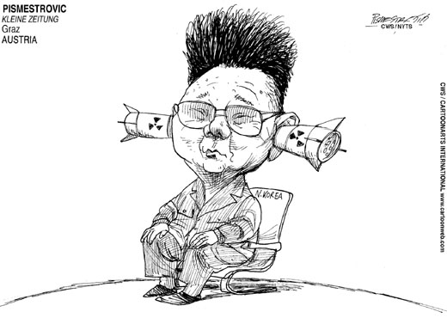

III. Funding the News

Operators of the small stations take pride in their independence, their feisty desire to get through to their brethren in the North on their own terms rather than as mouthpieces for large government-owned organizations. They too, however, depend on American funding for survival. The prime conduits have been the State Department and the National Endowment for Democracy. NED calls itself a “private non-profit foundation” but is “funded largely by the U.S. Congress,” was “created jointly by Republicans and Democrats,” and is “governed by a board balanced between both parties” while enjoying “congressional support across the political spectrum.” NED makes a point of transparency, listing precisely how much it gives each year to each beneficiary. The figures for 2009 included $150,000 each for Free North Korea Radio, Open Radio for North Korea and Radio Free Chosun and $175,000 for NK Communications to produce North Korea Reform Radio.
In keeping with its “belief that freedom is a universal human aspiration that can be realized through the development of democratic institutions, procedures, and values,” NED definitely has a monopoly on encouraging the non-governmental flow of information into North Korea. Daily NK got $145,000; Kim Sang-hun’s Database Center, $80,000, and Imjingang Publishing, publisher of Imjingang, a quarterly journal named for the Imjin River that flows from North to South Korea to the Yellow Sea, got $85,000 “for North Korean citizens to share information and opinions about North Korean culture, economics, politics, and other developments.” The magazine features reports by North Koreans who have smuggled themselves, and their material, out of the country. Given the funding for all these organizations, they’re not going to bite the hands that are feeding them; most of them also get funding, not specifically listed but all told about $1 million a year, from the State Department. (Kim Sang-hun denies the CIA is pitching in. “Basically,” he said, “the CIA is not interested in human rights in North Korea.”)
How effective is the media blitzkrieg? For a grant of another $50,000, InterMedia Survey Institute, a research firm located near NED’s offices in Washington, surveyed 250 refugees and “legal travelers” from North Korea in the Yanbian region between April 15 and August 31, 2009. Despite “expertise” drawn from former staffers of VOA and Radio Free Europe/Radio Liberty, another U.S. government network, the results were so vague as to raise doubts about the survey’s validity. “This year’s survey establishes that, even without strict media access selection criteria, North Korean refugees are listening to independent broadcasts inside North Korea,” said its slickly packaged report, acknowledging most respondents were from right across the Tumen River. “Starved for information,” it went on, “North Koreans are not very discriminating content consumers and seem to have very little brand preference” while “likely to listen to whatever broadcast they can receive most clearly.”

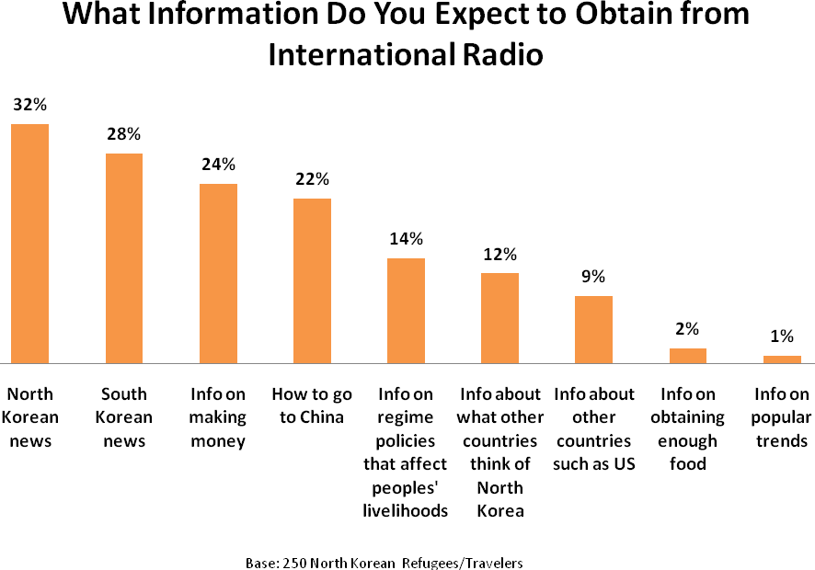

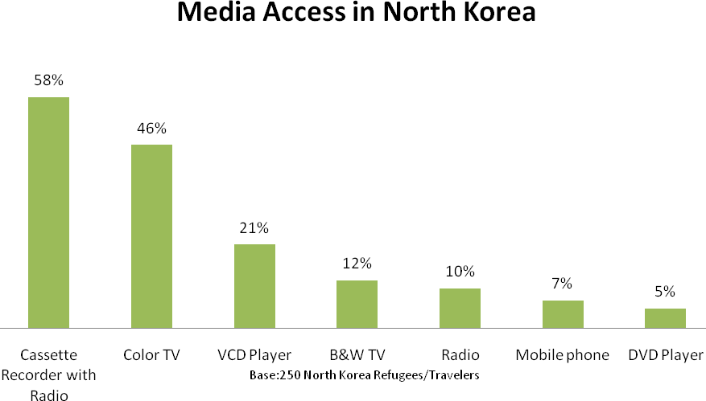
Inter-Media, “North Korean Refugee/Traveler Survey Report, April-August, 2009.” (The graphics give no hard figures on numbers of listeners surveyed or numbers of electronic receivers and do not reveal what percent of radios or TV sets pick up broadcasts from outside North Korea.)

One weakness of the survey lies in the use of phrases such as “had access to” – whether to a TV, a cassette with radio or a simple radio or a cell phone was not clear. “Access” could mean sharing with a friend or neighbor or anywhere else beyond the purview of the law. The survey found that “advanced technology is now much more common in North Korea than ever before,” that “many North Koreans are now watching VCD and DVDs, including many from South Korea,” and that “many defectors to China are able to keep in touch with those inside North Korea via cell phones.”
How many people actually are tuning in, for how long and how often, has never been certain despite extravagant claims. VOA in a press release said that “a US private research agency estimates that 36 percent of North Koreans listen to its programmes at least once a week” but did not name the agency or the basis for the estimate. Marcus Noland of the Peterson Institute found that 19 percent of 1,300 North Koreans polled in China and 300 in South Korea wanted to go to the U.S. despite “lifelong unrelenting exposure to anti-US propaganda” and surmised that was due to RFA and others “gradually penetrating North Korea.” There is, however, no way to verify this roseate analysis. Nor is it known exactly how or just where the 1,600 were selected, who interviewed them, under what conditions. Kim Sang-hun, after years of meeting defectors, attributes desires to go to the U.S. to stories heard when they got out of North Korea about how the U.S. was “the richest country in the world.” That poll, he said, showed “how blind and confused they are.”
In attempting to broadcast into North Korea, however, South Korean stations face one obstacle that would seem improbable considering the North-South confrontation. They all must spend 90 percent of their funding simply on buying the rights to use viable frequencies from foreign companies. “That’s because South Korea does not allow them to have short-wave frequencies,” said the official. “They buy frequencies from China, Mongolia and other nations. Regulation on these matters is less strict in China and Mongolia. Frequencies must be allocated. These stations are so small, and they don’t have enough money. It costs between five billion and ten billion won (nearly five million and ten million dollars) to buy the frequencies.” South Korean authorities are concerned about possible conflicts with major South Korean broadcasters. “There might be serious confusion,” he said. “It is problematic. We have discussed with government agencies. Right now it is impossible.” The government-run KBS carries broadcasts on mid-wave, short-wave and AM frequencies into North Korea, he explained, and RFA is able to use a frequency previously allocated to KBS.
Access to funding assures the biggest audiences tune in to RFA and VOA, for which the Broadcasting Board of Governors, an independent U.S. federal agency charged with all government-funded international broadcasting, allocated $.8.5 million in the 2010 fiscal year and $7.8 million the year before. Those figures are many times the $1 million that the State Department provided in 2010 for South Korean “programs to promote media freedom in North Korea (including, but not limited to, broadcasting).”
As a result, RFA and VOA probably claim 80 percent of the listeners in North Korea, meaning those who might listen as much as two or three time a week for ten to twenty minute each time. The duration of listening time is limited not just by the fear of discovery. Equally important, since virtually all radios run on batteries in a country in which plug-in sockets for electricity are largely non-existent, people must scrounge for batteries that are costly and hard to find. More often than not, they are smuggled in from China, along with cheap short-wave radios, and sold on the black markets that do business, sometimes quite openly, sometimes secretly.

IV. Ultimate Accolade: “Reptile’ Media

There is no doubt, though, that all these stations have one special core listenership: North Korean monitors hanging on their every word. Pyongyang’s Korean Central News Agency repeatedly denounces RFA and VOA in verbiage as flattering in a reverse way as any rave reviews for a book or show. North Korean rhetoricians have come to view RFA, with its exposé-type reporting, as more odious than the bland VOA but have bestowed on both the ultimate accolade, that of “reptile” media, a term not used to describe South Korean stations. After funds for RFA and VOA increased under the North Korea Human Rights Act of 2004, KCNA on January 2, 2008, reported “the U.S. intensified smear broadcasting “ as “part of its vicious moves to tarnish the image of the DPRK in the international arena and pull down the socialist system in the DPRK centered on the popular masses.” The article also charged “the U.S. has craftily worked hard to introduce transistor radios, CDs of unsavory contents and other publications through various channels into the DPRK in a bid to cause ideological and political vacillation, disintegration and degeneration among the people in the DPRK and social disorder.”
The Seoul-based stations also come in for their share of vituperation. After the inauguration of the conservative Lee Myung-bak as South Korea’s president in February 2008, the North’s Central Committee of the Democratic Front for the Reunification of the Fatherland blasted the South’s “right-wing conservatives” for having “gathered riffraff to set up such smear broadcastings as ‘broadcasting for the north,’ ‘missionary broadcasting for the north’ and ‘broadcasting for reform in the north’” as “a shock brigade in the campaign against the DPRK.” RFA and VOA, “speaking for the U.S. right-wing conservatives, are joining in,” said the tirade, “instigating the south (sic) Korean conservatives to do so.” Nor did the rhetoric omit Japan, vowing to “never overlook such provocative smear broadcasting launched by the south Korean conservative ruling quarters and the U.S. and Japanese reactionaries to dare to defame the destiny of the DPRK….”
Rajiv Narayan, in charge of investigations in Northeast Asia for Amnesty International in London, is guardedly hopeful despite terrible frustrations: “Most people we get to interview in South Korea or in China are from the border provinces in North Korea.” Along with “lack of access,” said Narayan, “is the difficulty of actually cross-checking episodes of human rights violations.” Sources are “never in North Korea but outside,” and there are “rarely two sources to cross-check.” And “on the rare occasions when we do get footage of human rights violations they lack further details such as where and when they took place, who were the victims, who were the perpetrators” and, above all, “is the footage credible?” Yes, he said, “I must admit gradually there is more information available, but the above questions on credible, cross-checkable information, especially in the area of human rights, remain.”
Kay Seok, researcher for Human Rights Watch, is not sure how much is changing. She doubts if many North Koreans have heard foreign broadcasts or, if they have, that they have had much impact; she believes most of the leaflets from balloons fall into the hands of soldiers near the Demilitarized Zone. She views the record on imprisonment and torture as fluctuating, not improving. “International efforts to engage North Korea on human rights have made strides in raising awareness and building pressure,” said Seok, “but there is still a long way to go to achieve fundamental change.”
Tom Coyner, an American business consultant with a long background in South Korea, believes that “most of the media comment on North Korean human rights” reflects “outside perspectives and indeed values sets.” Much as North Koreans might dislike “curtailment of daily freedoms under their local cadre,” Coyner wondered how many were “at all aware or concerned with the fundamental concept of ‘human rights.’” Any attempt “to tell North Koreans that they lack basic human rights could be viewed as a frontal attack on the core values – mythical or real -- of their society,” For starters, “one would have to patiently explain just what are human rights and why most people in other nations demand them” – “a most perplexing or inflammatory exercise.” Basically, Coyner distrusted “the relevance of what the western media may be broadcasting vis-à-vis the daily concerns of most North Koreans.”

V. Keeping up the Pressure

The anger of North Korean authorities over criticism on human rights, however, has convinced activists of the need for unremitting pressure. They are “highly sensitive to international media coverage,” said Michael Breen, a Seoul-based writer and consultant who has visited North Korea a number of times and met Kim Il-sung with a delegation of foreign journalists shortly before he died in July 1994. “Critical stories in the South Korean media caused problems for the rapprochement policy of Kim Dae-jung.” Author of a book on Kim Jong-il, Breen believes pressure on human rights abuses has had a certain qualified success. “In the early 1990s when they anticipated imminent ties with the United States and, with it, visits by U.S. congressmen thumping the table about human rights, justice officials in Pyongyang reviewed the possibility of ending the death penalty,” he said. “The purpose would be to have something over the U.S.,” Breen said, but Kim Il-sung’s death intervened. In any case, there has been no other report of North Korea ever considering giving up executions.
Norbert Vollertsen, a German doctor who spent 18 months in North Korea before his expulsion in early 2001 for revealing the ills of the medical system, credits media reports with having had some effect, albeit unproven, on the lives of those caught up in the gulag system. “Yes, I still think media works when it comes to get a picture about the bad situation in North Korea,” said Vollertsen, “I learned from some North Korean refugees the situation in some gulags is improving because the North Koreans know about this watching media eye.” In Pyongyang, “North Koreans “do not want to lose their face in the media world,” he said. “They are very concerned about their dignity, their pride about Korean culture, ‘real socialism,’ etc. And their only luck so far is that there was not so much interest in tiny North Korea.” In a new regime, North Korea may be expected to want to intensify that interest while shielding visitors, counting on gullible correspondents, on tightly constricted tours, to give a favorable view reflecting what little they see and hear.

The author, with his guide and others in his tour group, has stood in front of the Kim Il-sung statue on each of his four visits to Pyongyang, in 1992, 1995, 2005 and 2008.
Jean H. Lee, Associated Press, “A Rare Glimpse at a Different Side of North Korea,” October 10, 2010.
The Korea Times, June 1, 2010.
Reporters Without Borders, “Call for more international support for exile radios after station director wins award, “ November 6, 2009, http://en.rsf.org/north-korea-call-for-more-international-06-11-2009,34926,
VOA, “Voice of America to Expand Korean Service,” press release, December 06, 2006; Kyodo, “FOCUS: Voice of America boosting programs targeted at N. Korea,” Washington, November 30, 2009
Radio Free Asia, “Radio Free Asia’s Korea Operations,” March 2010.
Ibid.
National Endowment for Democracy, “About NED,” www.ned.org.
National Endowment for Democracy, “Active North Korea-Related Projects,” Washington, March 2010.
Ibid. Imjingang broke off in 2009 from its former Japanese partner, Rimjingang, based in Osaka, which also publishes articles about North Korean issues. Rimjingang is not funded by NED.
Interview, Kim Sang-hun, Seoul, August 2010.
Inter-Media, “International Broadcasting in North Korea: North Korea Refugee/Traveler Survey Report,” Washington, April-August 2009, pp. 5-6.
Ibid., pp. 4-5.
VOA, press release, December 06, 2006
Agence France Presse, April 30, 2009, reporting on survey released on April 29, 2009. RFA also cited Marcus Noland’s report in “Radio Free Asia’s Korea Operations,” March 2010.
Interview, Kim Sang-hun, Seoul, August 2010.
Ibid.
U.S. embassy, Seoul, provided these figures, October 5, 2010, in response to the author’s query.
Korean Central News Agency, “U.S. Criminal Smear Campaign against DPRK Disclosed,” Pyongyang, January 2, 2008.
Korean Central News Agency, “Anti-DPRK Smear Broadcasting Campaign Accused,” Pyongyang, March 16, 2008.
Rajiv Narayan to the author, email, August 3, 2010.
Kay Seok, “Why We Need to Keep the Spotlight on North Korea,” Huffington Post, March 2010
Tom Coyner to the author, email, August 4, 2010.
Michael Breen to the author, email, August 5, 2010.
Norbert Vollertsen to the author, email, August 3, 2010.

